VISVESVARAYA TECHNOLOGICAL UNIVERSITY
“JnanaSangama”, Belgaum -590014, Karnataka.

LAB REPORT
on
Artificial Intelligence (23CS5PCAIN)

Submitted by
ARYAN NAVLANI(1BM23CS055)

in partial fulfillment for the award of the degree of
BACHELOR OF ENGINEERING
in
COMPUTER SCIENCE AND ENGINEERING


B.M.S. COLLEGE OF ENGINEERING
(Autonomous Institution under VTU)
BENGALURU-560019
Aug 2025 to Dec 2025

B.M.S. College of Engineering,
Bull Temple Road, Bangalore 560019
(Affiliated To Visvesvaraya Technological University, Belgaum)
Department of Computer Science and Engineering


CERTIFICATE

This is to certify that the Lab work entitled “Artificial Intelligence (23CS5PCAIN)” carried out by ARYAN NAVLANI(1BM23CS055), who is bonafide student of B.M.S. College of Engineering. It is in partial fulfillment for the award of Bachelor of Engineering in Computer Science and Engineering of the Visvesvaraya Technological University, Belgaum. The Lab report has been approved as it satisfies the academic requirements in respect of an Artificial Intelligence (23CS5PCAIN) work prescribed for the said degree.

Lab faculty  Sandhya A Kulkarni  Assistant Professor Department of CSE, BMSCE | Dr. Kavitha Sooda Professor & HOD  Department of CSE, BMSCE

Index
Sl.  No. | Date | Experiment Title | Page No.
1 | 30-9-2024 | Implement Tic –Tac –Toe Game Implement vacuum cleaner agent
2 | 7-10-2024 | Implement 8 puzzle problems using Depth First Search (DFS)  Implement Iterative deepening search algorithm
3 | 14-10-2024 | Implement A* search algorithm
4 | 21-10-2024 | Implement Hill Climbing search algorithm to solve N-Queens problem
5 | 28-10-2024 | Simulated Annealing to Solve 8-Queens problem
6 | 11-11-2024 | Create a knowledge base using propositional logic and show that the given query entails the knowledge base or not.
7 | 2-12-2024 | Implement unification in first order logic
8 | 2-12-2024 | Create a knowledge base consisting of first order logic statements and prove the given query using forward reasoning.
9 | 16-12-2024 | Create a knowledge base consisting of first order logic statements and prove the given query using Resolution
10 | 16-12-2024 | Implement Alpha-Beta Pruning.

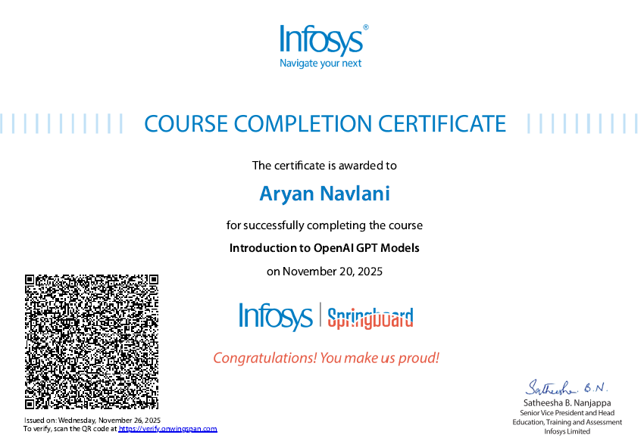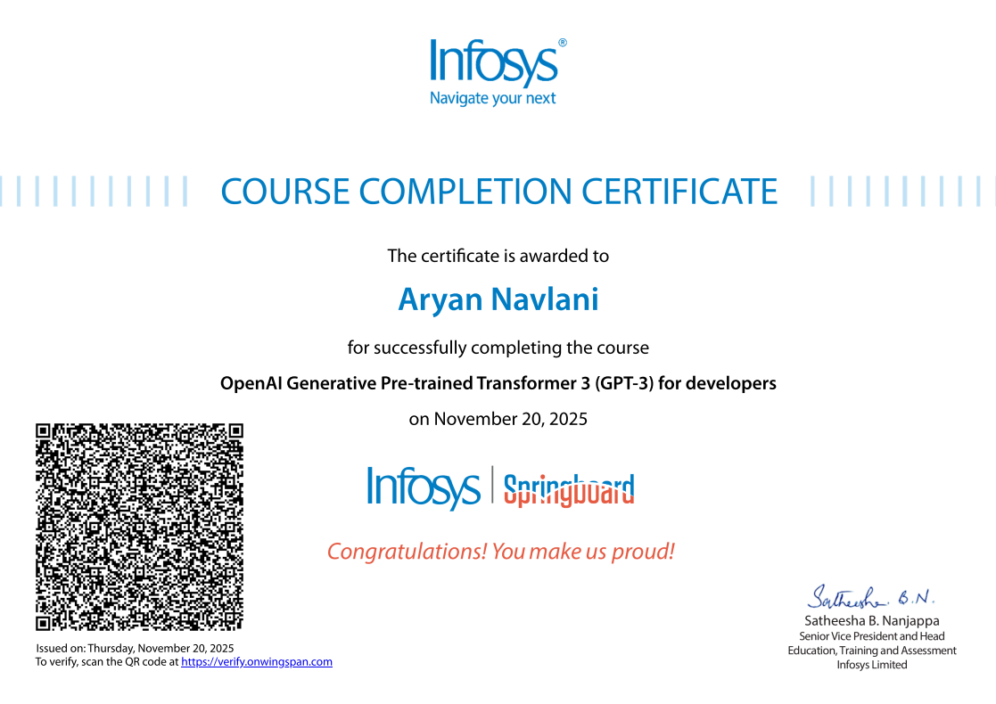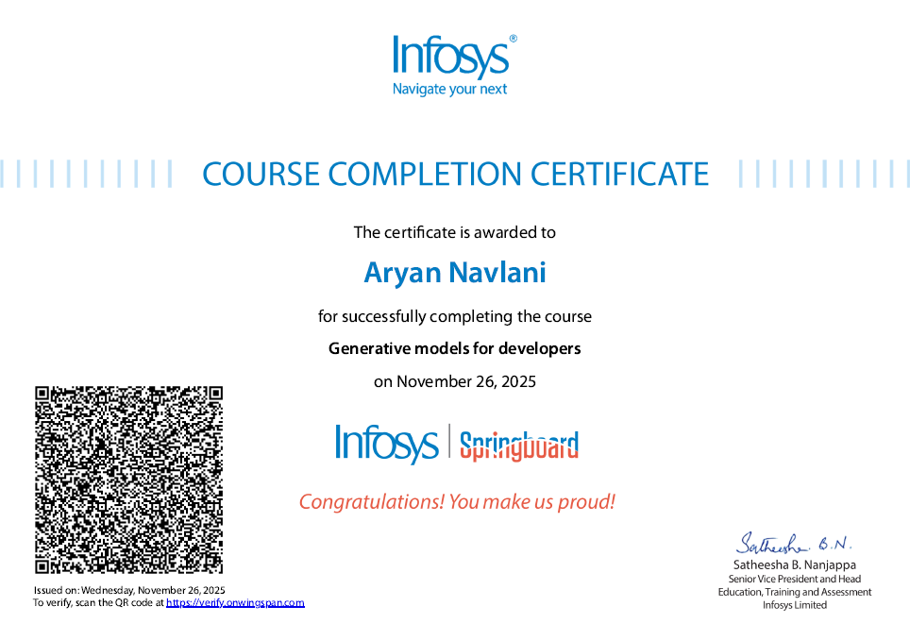
Github Link: https://github.com/1BM23CS055/AI-LAB

Program 1
Implement Tic –Tac –Toe Game Implement vacuum cleaner agent

Algorithm:
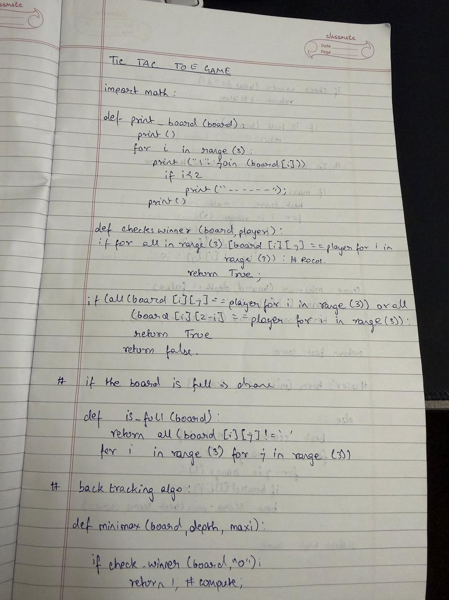

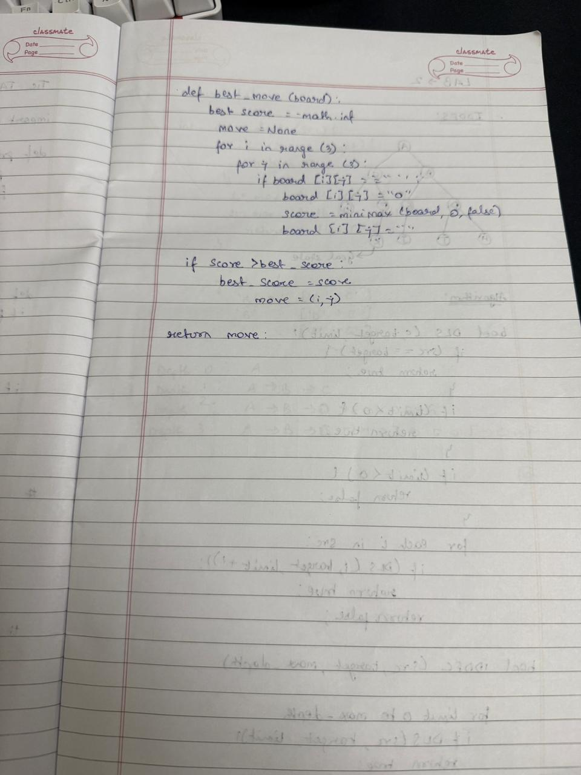
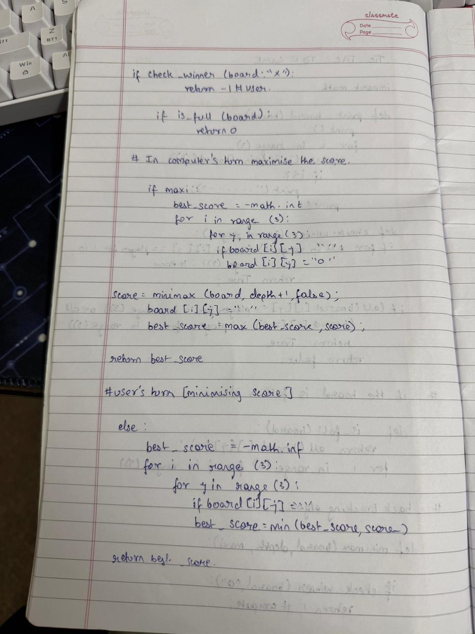Code:

def print_board(board): for row in board:
print(" ".join(row)) print()

def check_winner(board, player): for i in range(3):
if all(board[i][j] == player for j in range(3)): return True if all(board[j][i] == player for j in range(3)): return True if all(board[i][i] == player for i in range(3)): return True
if all(board[i][2 - i] == player for i in range(3)): return True return False
def is_draw(board):
return all(board[i][j] != '-' for i in range(3) for j in range(3))

def minimax(board, is_ai_turn):
if check_winner(board, 'O'): # AI win return 1
if check_winner(board, 'X'): # Player win return -1 if is_draw(board):
return 0

if is_ai_turn:
best_score = -float('inf') for i in range(3):
for j in range(3):
if board[i][j] == '-':
board[i][j] = 'O'
score = minimax(board, False) board[i][j] = '-' best_score = max(score, best_score) return best_score else:
best_score = float('inf') for i in range(3):
for j in range(3):
if board[i][j] == '-':
board[i][j] = 'X'
score = minimax(board, True) board[i][j] = '-' best_score = min(score, best_score) return best_score
def manual_game():
board = [['-' for _ in range(3)] for _ in range(3)] print("Initial Board:") print_board(board)

while True:
# Input X move while True:
try:
x_row = int(input("Enter X row (1-3): ")) - 1 x_col = int(input("Enter X col (1-3): ")) - 1 if board[x_row][x_col] == '-': board[x_row][x_col] = 'X' break
else:
print("Cell occupied!") except:
print("Invalid input!")
print("Board after X move:") print_board(board) if check_winner(board, 'X'):
print("X wins!") break if is_draw(board):
print("Draw!") break

# Input O move while True:
try:
o_row = int(input("Enter O row (1-3): ")) - 1 o_col = int(input("Enter O col (1-3): ")) - 1

if board[o_row][o_col] == '-': board[o_row][o_col] = 'O' break else:
print("Cell occupied!") except:
print("Invalid input!")
print("Board after O move:") print_board(board) if check_winner(board, 'O'): print("O wins!") break
if is_draw(board):
print("Draw!") break

# AI evaluates the board (from current position)
cost = minimax(board, True) # AI's turn to move next print(f"AI evaluation cost from this position: {cost}") manual_game()

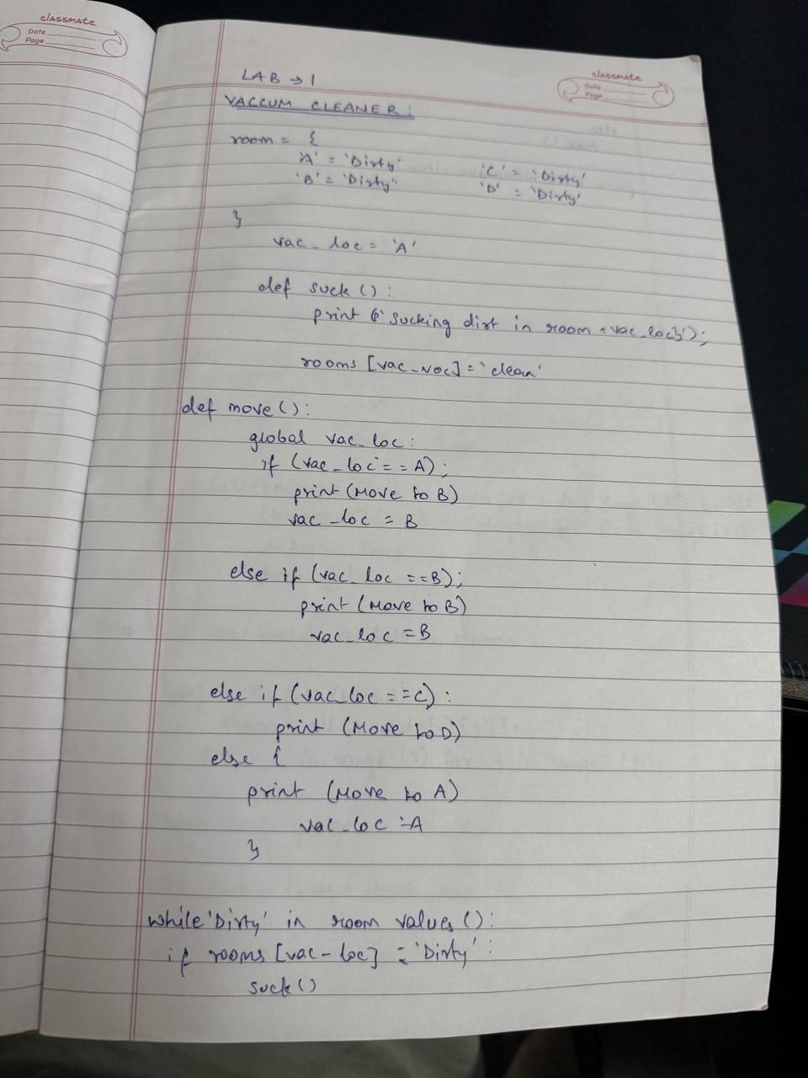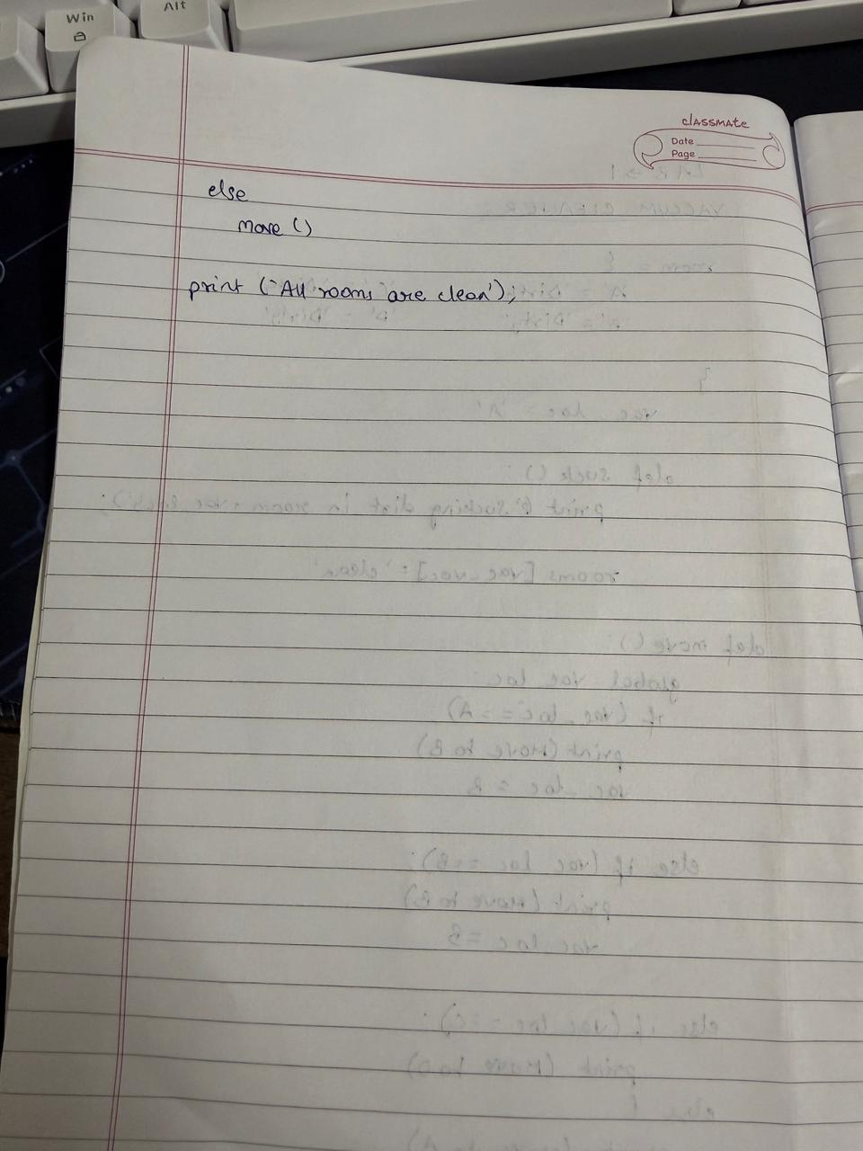

Code:

def vacuum_cleaner():
# Taking user input for the state of each room
state_A = int(input("Enter state of A (0 for clean, 1 for dirty): ")) state_B = int(input("Enter state of B (0 for clean, 1 for dirty): ")) state_C = int(input("Enter state of C (0 for clean, 1 for dirty): ")) state_D = int(input("Enter state of D (0 for clean, 1 for dirty): ")) location = input("Enter location (A, B, C, or D): ").upper()

cost = 0
rooms = {'A': state_A, 'B': state_B, 'C': state_C, 'D': state_D}
# Function to clean a room and update the cost def clean_room(room): nonlocal cost
if rooms[room] == 1: print(f"Cleaned {room}.") rooms[room] = 0 cost += 1 else:
print(f"{room} is clean.")
if location == 'A': clean_room('A') print("Moving vacuum right") clean_room('B')
print("Moving vacuum down") clean_room('D') print("Moving vacuum left") clean_room('C')
elif location == 'B': clean_room('B') print("Moving vacuum left") clean_room('A')
print("Moving vacuum down") clean_room('D') print("Moving vacuum right") clean_room('C')

elif location == 'C': clean_room('C') print("Moving vacuum right") clean_room('D')
print("Moving vacuum up") clean_room('B') print("Moving vacuum left") clean_room('A')
elif location == 'D': clean_room('D') print("Moving vacuum up") clean_room('B')
print("Moving vacuum right")
clean_room('C') print("Moving vacuum left") clean_room('A')

else:
print("Invalid starting location!")

print(f"Cost: {cost}") print("Room states:", rooms)

Program 2

Implement 8 puzzle problems using Depth First Search (DFS) Implement Iterative deepening search algorithm

Algorithm:
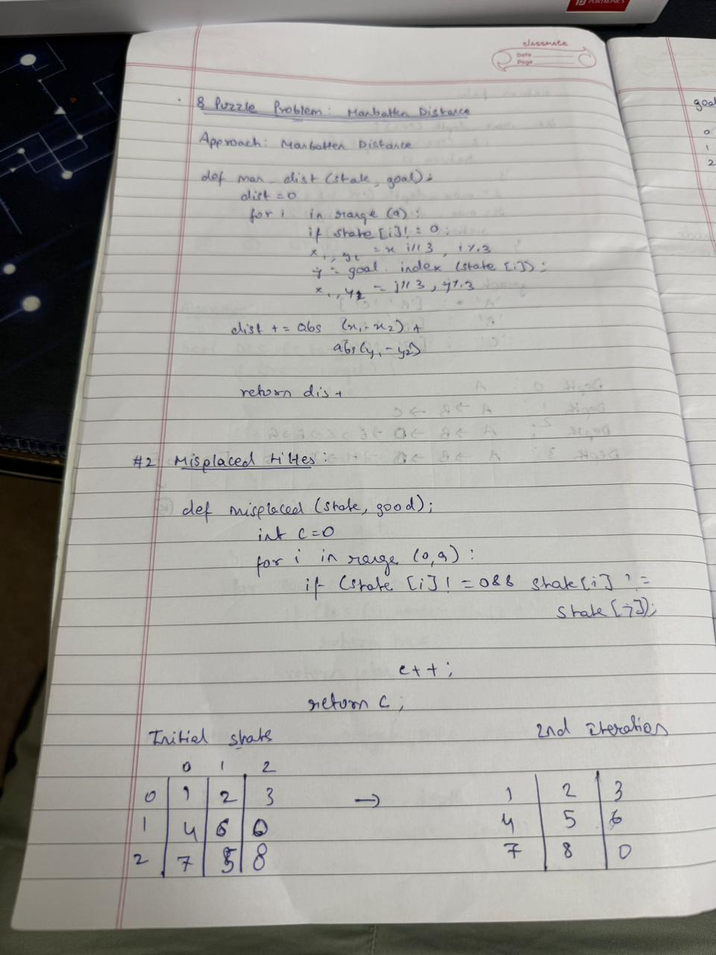

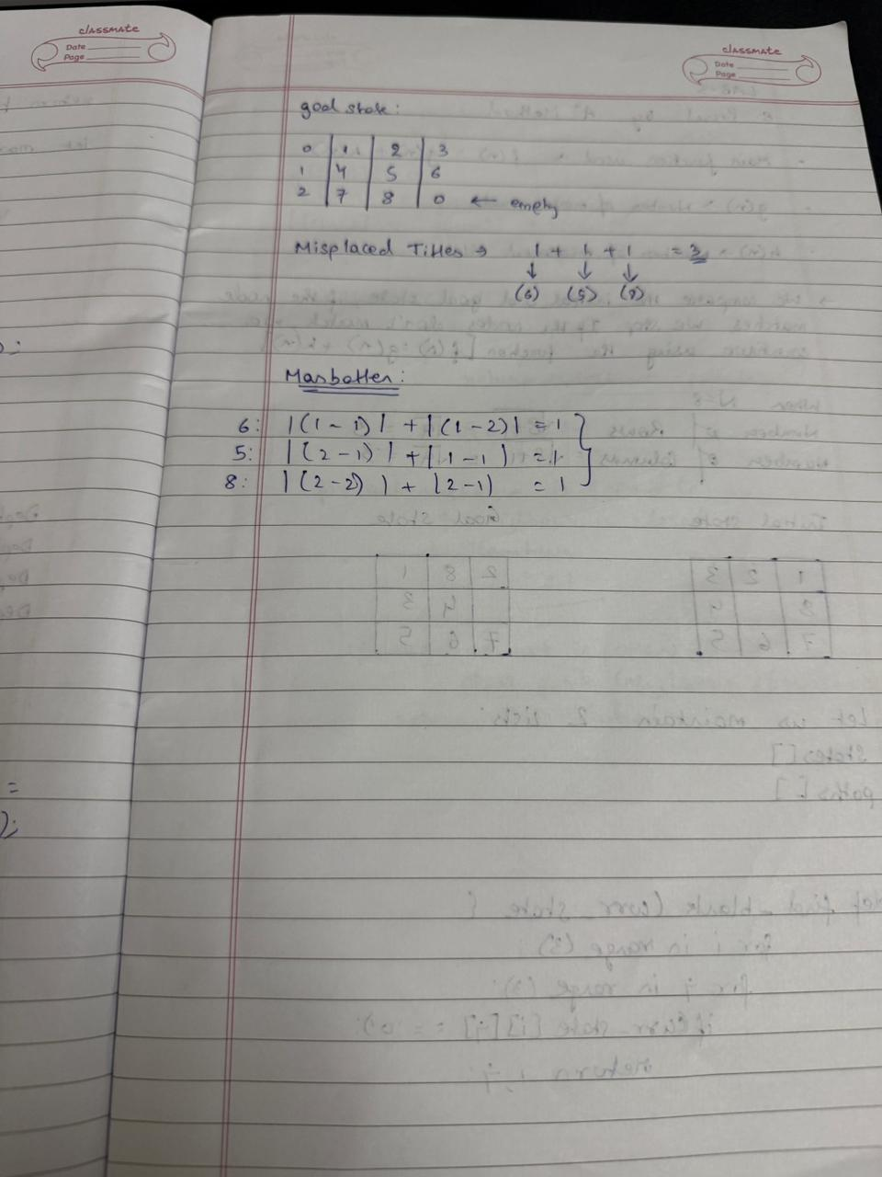

Code:
from collections import deque def find_blank(state):
"""Finds the position of the blank tile (0).""" for i in range(3): for j in range(3):
if state[i][j] == 0: return (i, j)def get_neighbors(state):
"""Generates all possible next states from the current state.""" neighbors = [] blank_row, blank_col = find_blank(state)
moves = [(0, 1), (0, -1), (1, 0), (-1, 0)] # Right, Left, Down, Up

for move_row, move_col in moves:
new_row, new_col = blank_row + move_row, blank_col + move_col

if 0 <= new_row < 3 and 0_state = ( (1, 2, 3),
(4, 0, 5),
(6, 7, 8)
)

goal_state = ( (1, 2, 3),
(4, 5, 6),
(7, 8, 0)
)

solution_path = dfs(initial_state, goal_state) if solution_path: print("Solution Found!")
for i, state in enumerate(solution_path): print(f"Step {i+1}:") for row in state: print(row)
print("-" * 10) else: print("No solution exists.")

Program 3
Implement A* search algorithm

Algorithm:

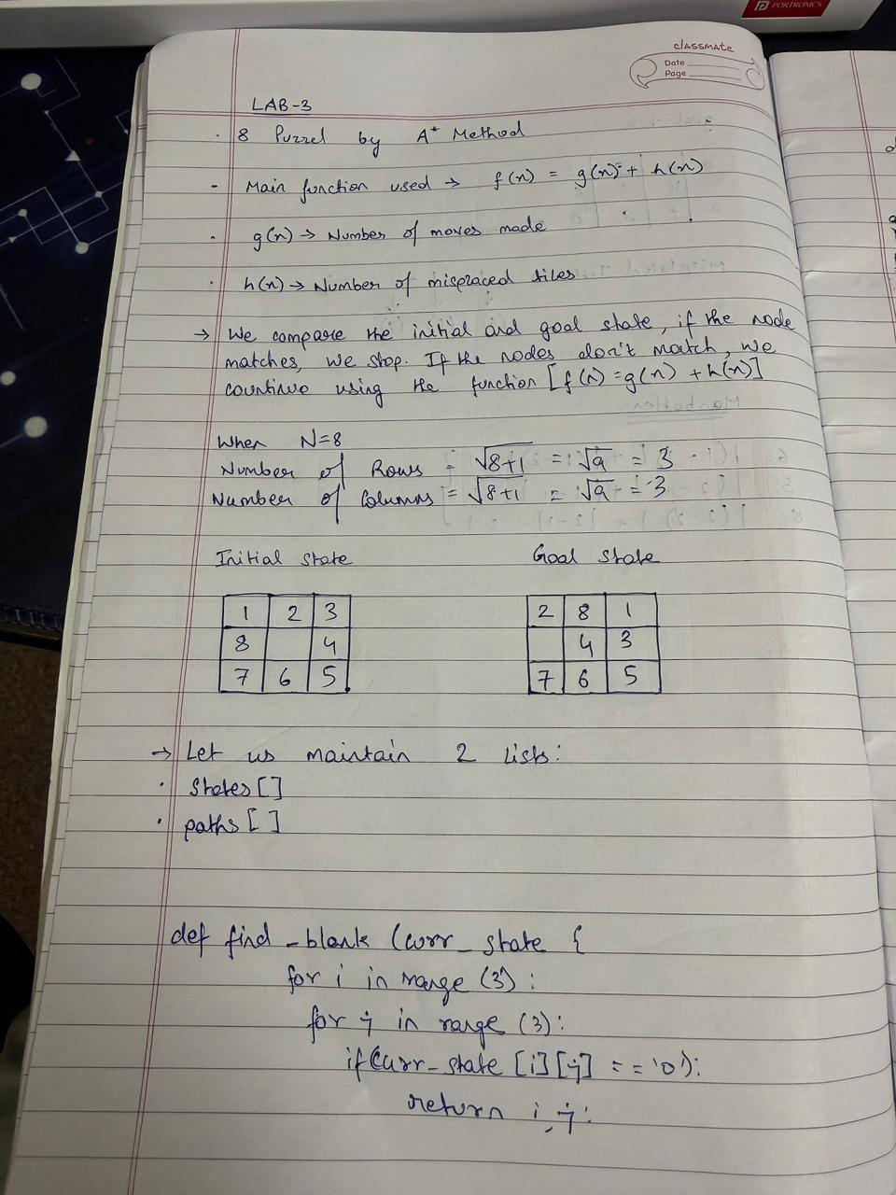

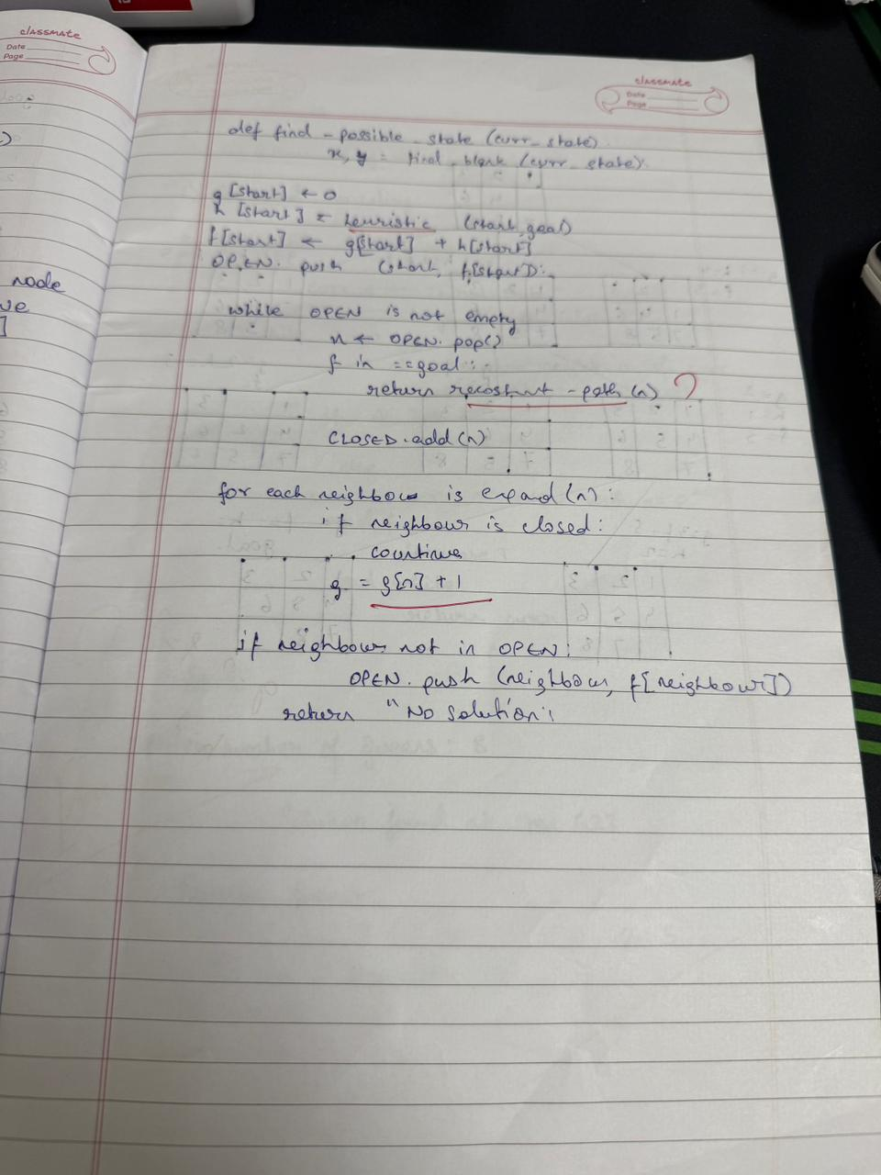

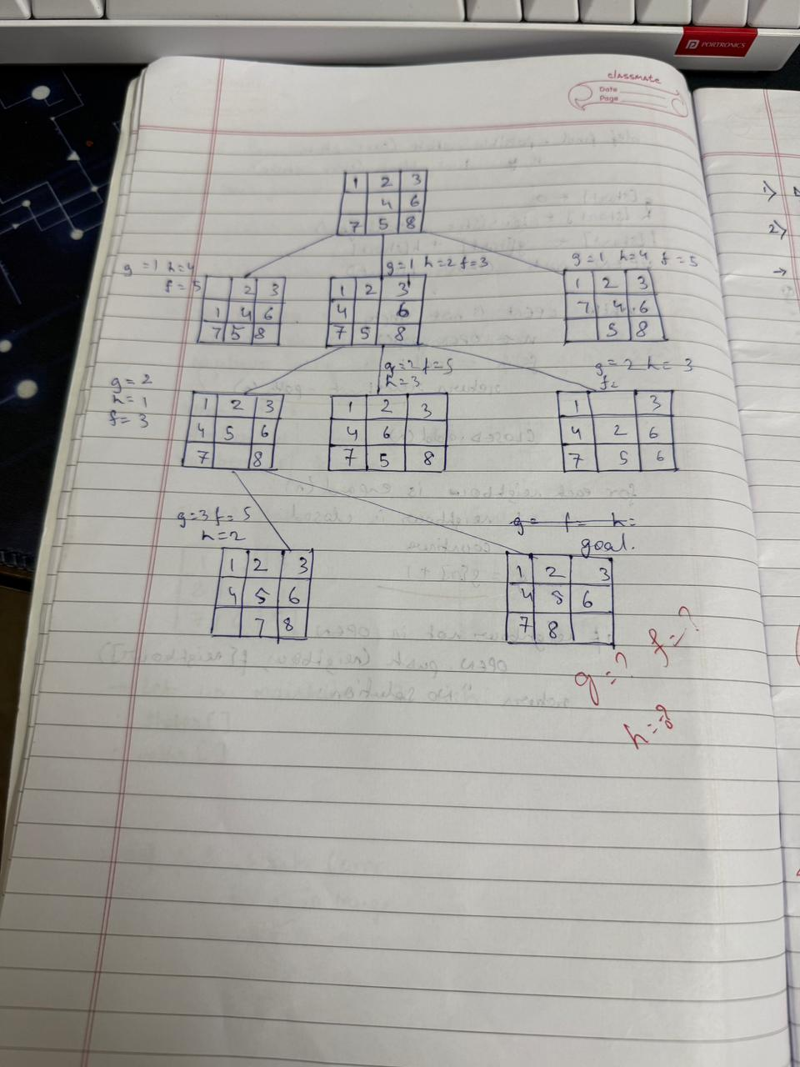

Code:

import heapq
def manhattan_distance(state, goal): distance = 0 for i in range(3): for j in range(3):
if state[i][j] != 0: value = state[i][j]
# Find the position of the value in the goal state for gi in range(3):
for gj in range(3):
if goal[gi][gj] == value: goal_pos = (gi, gj) break else:
continue break
distance += abs(i - goal_pos[0]) + abs(j - goal_pos[1]) return distance

def get_neighbors(state): neighbors = [] for i in range(3): for j in range(3):
if state[i][j] == 0: x, y = i, j break else:
continue break

moves = [(0, 1), (0, -1), (1, 0), (-1, 0)]
for dx, dy in moves:
nx, ny = x + dx, y + dy
if 0 <= nx < 3 and 0 <= ny < 3:

new_state = [list(row) for row in state]
new_state[x][y], new_state[nx][ny] = new_state[nx][ny], new_state[x][y] neighbors.append(tuple(tuple(row) for row in new_state))
return neighbors
def astar_search_manhattan(initial, goal):
frontier = [(manhattan_distance(initial, goal), 0, initial)] explored = set() parent = {}
cost = {initial: 0}
while frontier:
f, g, current = heapq.heappop(frontier)

if current == goal: path = []
while current in parent: path.append(current) current = parent[current] path.append(initial) return path[::-1]
explored.add(current)

for neighbor in get_neighbors(current): new_cost = cost[current] + 1
if neighbor not in cost or new_cost < cost[neighbor]: cost[neighbor] = new_cost
priority = new_cost + manhattan_distance(neighbor, goal) heapq.heappush(frontier, (priority, new_cost, neighbor)) parent[neighbor] = current
return None

def get_state_input(prompt): print(prompt) state = []
for _ in range(3):
row = list(map(int, input().split()))

state.append(row)
return tuple(tuple(row) for row in state)

initial_state_m = get_state_input("Enter the initial state for Manhattan distance (3 rows of 3 numbers separated by spaces, use 0 for the blank):")
goal_state_m = get_state_input("Enter the goal state for Manhattan distance (3 rows of 3 numbers separated by spaces, use 0 for the blank):")
path_m = astar_search_manhattan(initial_state_m, goal_state_m) if path_m: print("Solution found using Manhattan distance:")
for step in path_m: for row in step:
print(row) print() else:
print("No solution found using Manhattan distance.")

Program 4
Implement Hill Climbing search algorithm to solve N-Queens problem

Algorithm
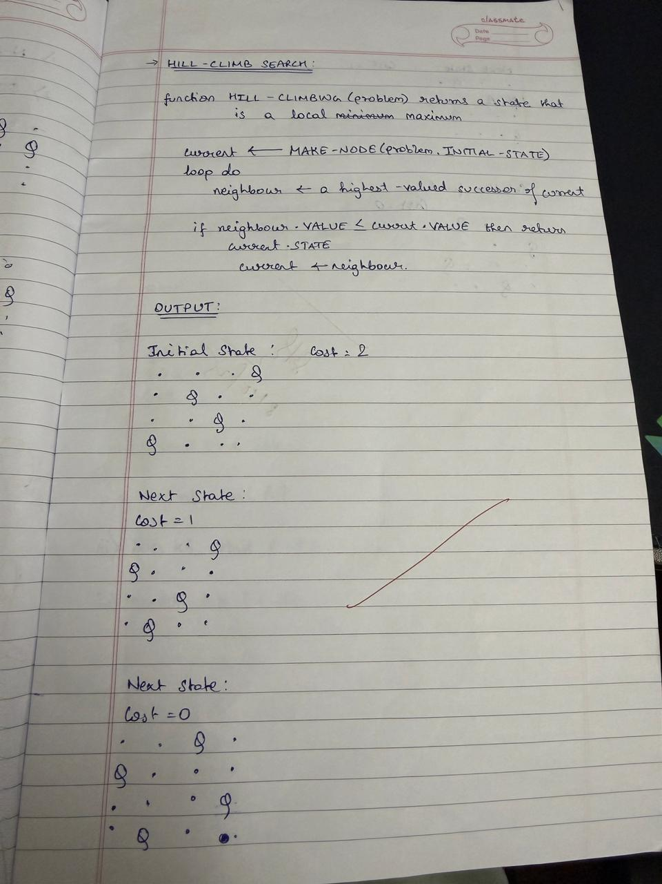

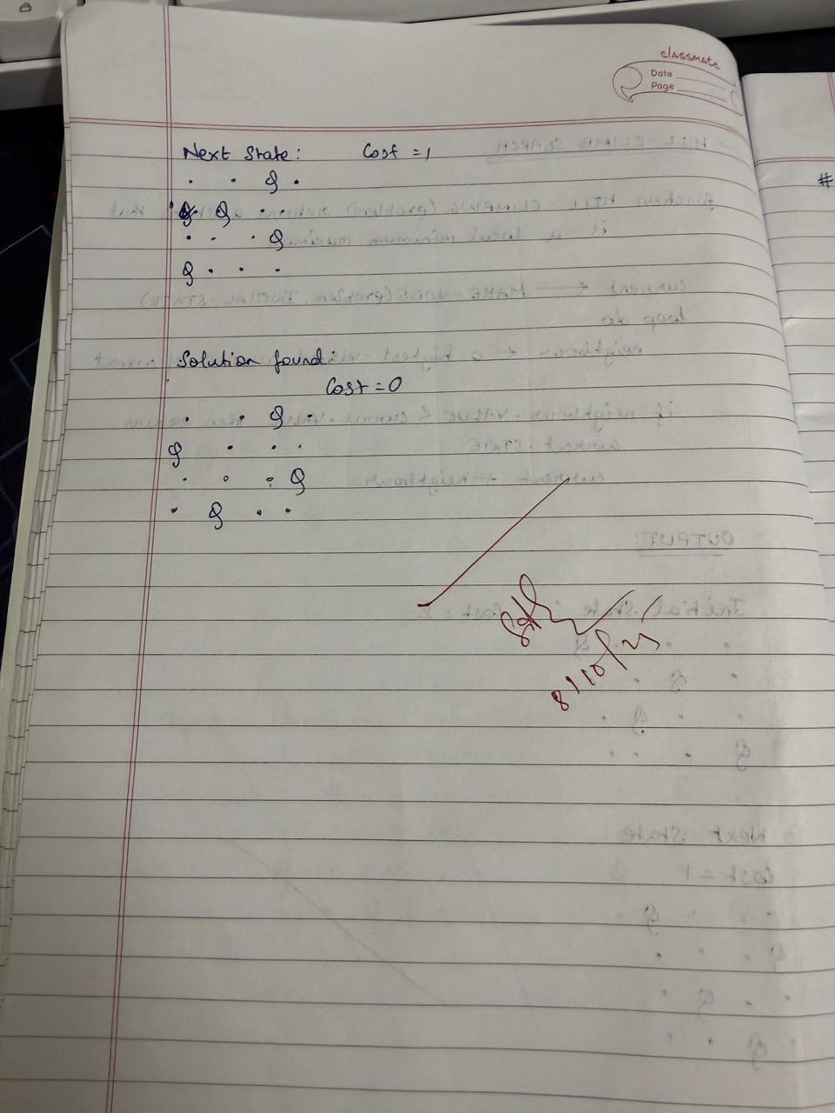

Code:

import random def cost(state):
attacking_pairs = 0 n = len(state) for i in range(n

for j in range(i + 1, n):
if state[i] == state[j] or abs(state[i] - state[j]) == abs(i - j):
attacking_pairs += 1 return attacking_pairs
def print_board(state):

n = len(state)
board = [['.' for _ in range(n)] for _ in range(n)] for i in range(n):
board[state[i]][i] = 'Q'

for row in board: print(" ".join(row)) def get_neighbors(state):
neighbors = [] n = len(state) for i in range(n):
for j in range(i + 1, n): neighbor = list(state)
neighbor[i], neighbor[j] = neighbor[j], neighbor[i] neighbors.append(tuple(neighbor)) return neighbors
def hill_climbing(initial_state):
current = initial_state print(f"Initial state:") print_board(current) print(f"Cost: {cost(current)}") print('-' * 20) while True:
neighbors = get_neighbors(current)

next_state = min(neighbors, key=lambda x: cost(x)) print(f"Next state:") print_board(next_state)

print(f"Cost: {cost(next_state)}") print('-' * 20) if cost(next_state) >= cost(current):
print(f"Solution found:") print_board(current) print(f"Cost: {cost(current)}") return current current = next_state if name == " main ":
initial_state = (3, 1, 2, 0)

Program 5
Simulated Annealing to Solve 8-Queens problem

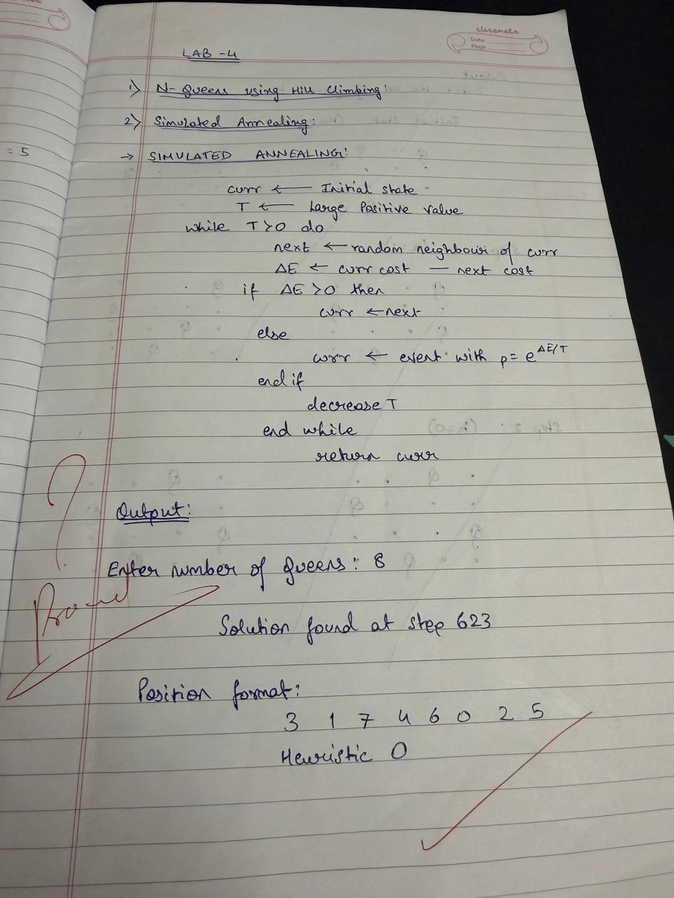
Algorithm:

Code:
import random import math
def calculate_cost(state): cost = 0
n = len(state) for i in range(n):
for j in range(i + 1, n):
if state[i] == state[j] or abs(state[i] - state[j]) == abs(i - j): cost += 1
return cost

def get_random_neighbor(state): n = len(state)
new_state = list(state)
col = random.randint(0, n - 1) row = random.randint(0, n - 1) new_state[col] = row
return new_state
def simulated_annealing(n=8, max_iterations=10000, initial_temp=100.0, cooling_rate=0.99): current = [random.randint(0, n - 1) for _ in range(n)]
current_cost = calculate_cost(current) best = current
best_cost = current_cost temperature = initial_temp

for _ in range(max_iterations): if current_cost == 0:
break

neighbor = get_random_neighbor(current) neighbor_cost = calculate_cost(neighbor) delta = neighbor_cost - current_cost

if delta < 0 or random.random() < math.exp(-delta / temperature): current, current_cost = neighbor, neighbor_cost
if current_cost < best_cost:
best, best_cost = current, current_cost

temperature *= cooling_rate if temperature < 1e-6:
break

return best, best_cost

best_state, best_cost = simulated_annealing() print("The best position found:", best_state)

print("cost =", best_cost)

Output:
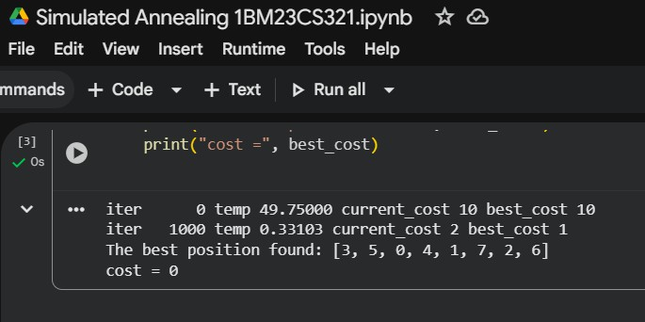

Program 6

Create a knowledge base using propositional logic and show that the given query entails the knowledge base or not.

Algorithm:
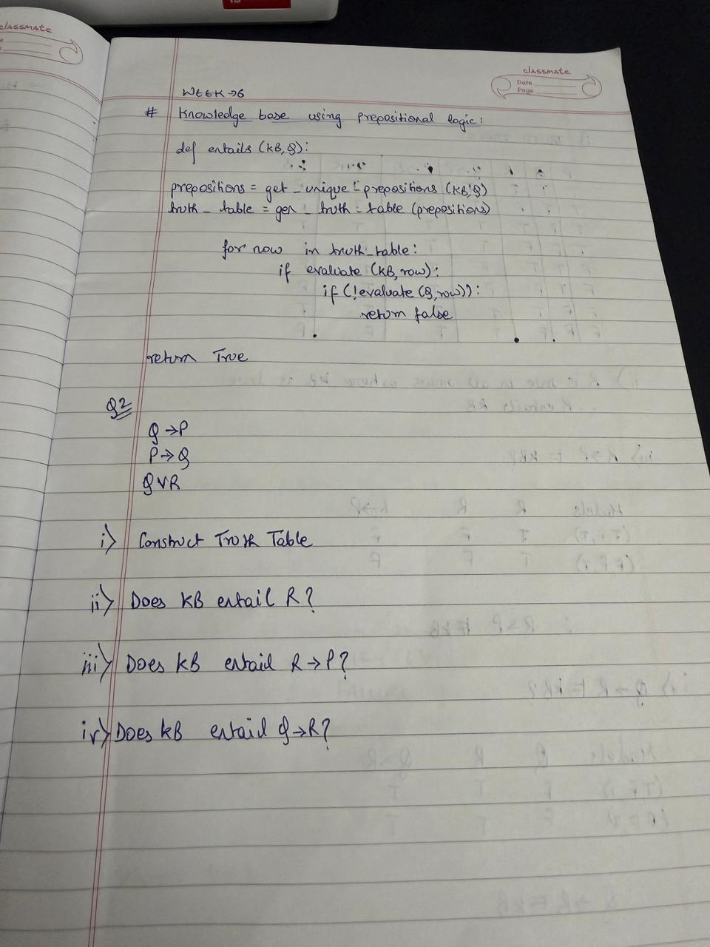

Code:
import itertools

def eval_expr(expr, model): try:
return eval(expr, {}, model) except:
return False
def tt_entails(KB, query):
symbols = sorted(set([ch for ch in KB + query if ch.isalpha()]))
print("\nTruth Table:")
print(" | ".join(symbols) + " | KB | Query") print("-" * (6 * len(symbols) + 20))
entails = True
for values in itertools.product([False, True], repeat=len(symbols)): model = dict(zip(symbols, values))
kb_val = eval_expr(KB, model) query_val = eval_expr(query, model)

row = " | ".join(["T" if model[s] else "F" for s in symbols]) print(f"{row} | {kb_val} | {query_val}")
if kb_val and not query_val: entails = False

return entails

KB = input("Enter Knowledge Base (use &, |, ~ for AND, OR, NOT): ") query = input("Enter Query: ")
result = tt_entails(KB, query) print("\nResult:")
if result:
print("KB entails Query (True in all cases).") else:
print("KB does NOT entail Query.")

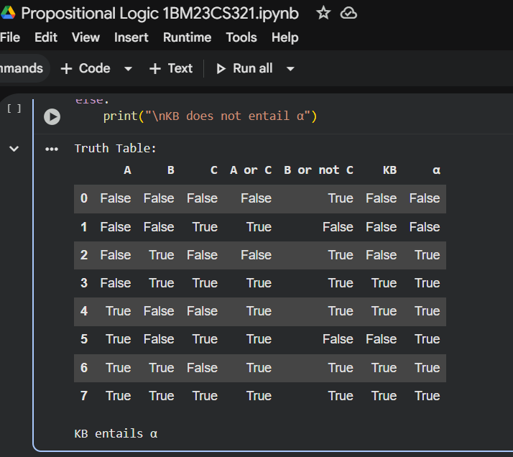
Output:

Program 7

Implement unification in first order logic

Algorithm:
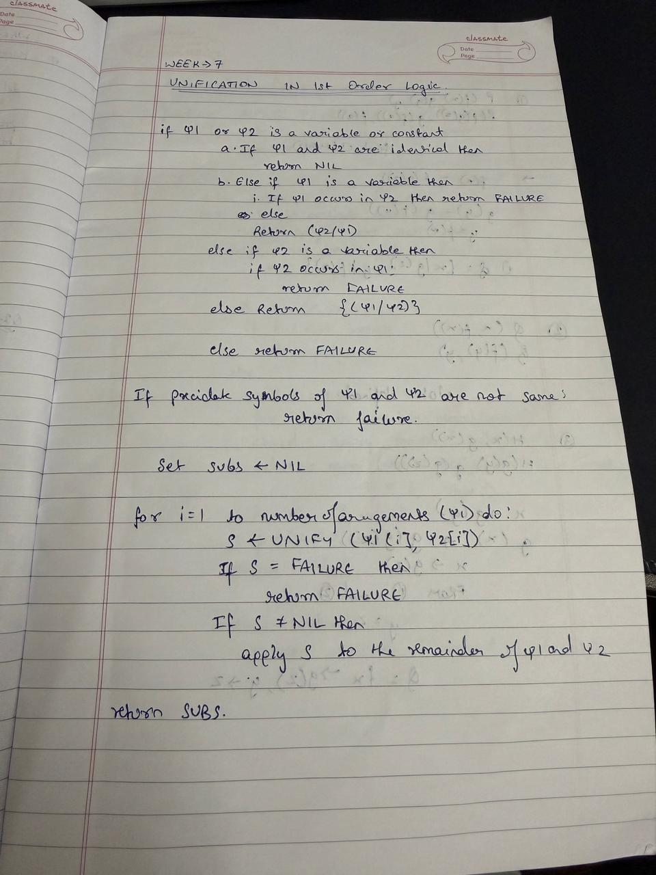

Code:
def occurs_check(var, term, subst): if var == term:

return True
elif isinstance(term, tuple):
return any(occurs_check(var, t, subst) for t in term) elif term in subst:
return occurs_check(var, subst[term], subst) return False
def unify(x, y, subst): if subst is None:
return None elif x == y:
return subst
elif isinstance(x, str) and x.isupper(): return unify_var(x, y, subst)
elif isinstance(y, str) and y.isupper(): return unify_var(y, x, subst)
elif isinstance(x, tuple) and isinstance(y, tuple): if x[0] != y[0] or len(x) != len(y):
return None
for a, b in zip(x[1:], y[1:]): subst = unify(a, b, subst) if subst is None:
return None return subst
else:
return None

def unify_var(var, x, subst): if var in subst:
return unify(subst[var], x, subst) elif x in subst:
return unify(var, subst[x], subst) elif occurs_check(var, x, subst):
return None else:
subst[var] = x return subst
def parse_expr(s):
s = s.replace(" ", "") if '(' not in s:
return s
name_end = s.index('(') name = s[:name_end] args = []
depth = 0 current = ""
for c in s[name_end+1:-1]: if c == ',' and depth == 0:
args.append(parse_expr(current)) current = ""
else:

if c == '(': depth += 1
elif c == ')': depth -= 1
current += c if current:
args.append(parse_expr(current)) return tuple([name] + args)

def expr_to_str(expr):
if isinstance(expr, tuple):
return expr[0] + "(" + ",".join(expr_to_str(e) for e in expr[1:]) + ")" else:
return expr

expr1_input = input("Enter first expression: ") expr2_input = input("Enter second expression: ")

expr1 = parse_expr(expr1_input) expr2 = parse_expr(expr2_input)
subst = unify(expr1, expr2, {})
if subst:
formatted_subst = {var: expr_to_str(val) for var, val in subst.items()} else:
formatted_subst = None
print("Most General Unifier (MGU):", formatted_subst)

Output:
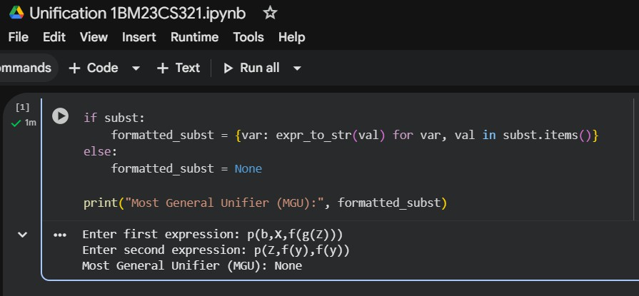

Program 8

Create a knowledge base consisting of first order logic statements and prove the given query using forward reasoning.

Algorithm:
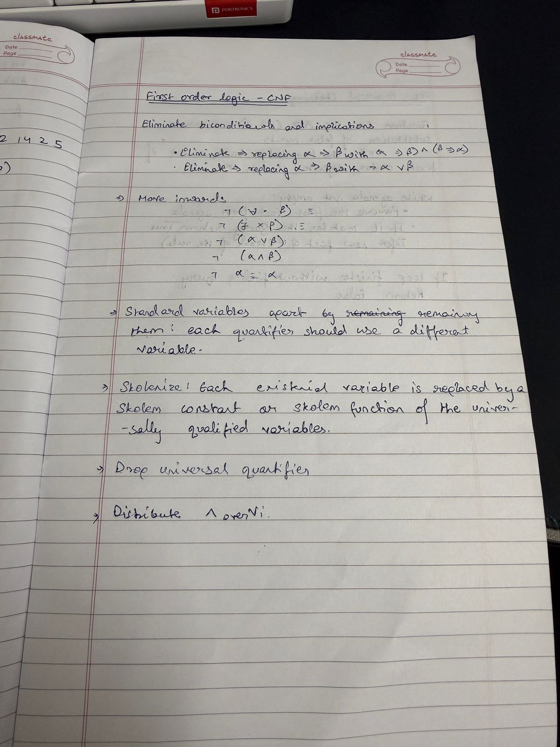

Code:
facts = {

'American(Robert)': True, 'Hostile(A)': True, 'Sells_Weapons(Robert, A)': True
}

If American(X) and Hostile(Y) and Sells_Weapons(X, Y), then Crime(X) def forward_reasoning(facts):

If American(X) and Hostile(Y) and Sells_Weapons(X, Y), then Crime(X)
if facts.get('American(Robert)', False) and facts.get('Hostile(A)', False) and facts.get('Sells_Weapons(Robert, A)', False):
facts['Crime(Robert)'] = True forward_reasoning(facts)
if facts.get('Crime(Robert)', False): print("Robert is a criminal.")
else:
print("Robert is not a criminal.")

Output:
Robert is a criminal.

Program 9

Create a knowledge base consisting of first order logic statements and prove the given query using Resolution

Algorithm:
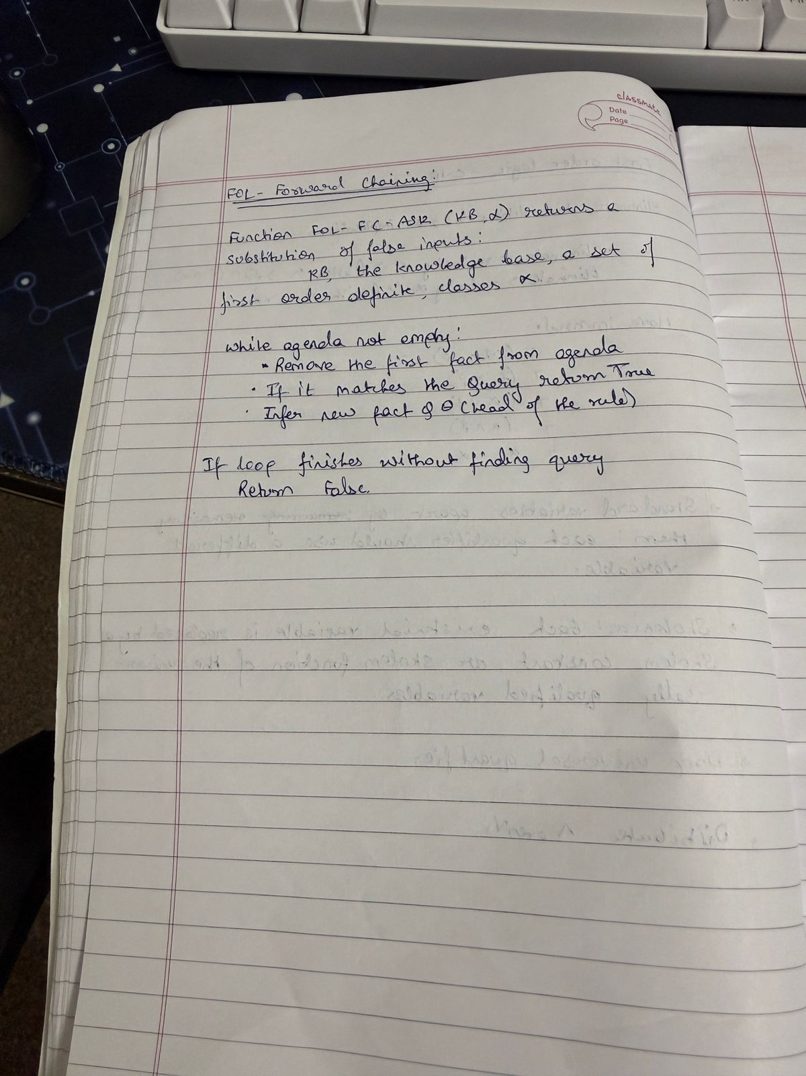

Code:
def fol_resolution(kb, query): print("\n" + "="*55)
print(" KNOWLEDGE BASE")
print("="*55)
for i, clause in enumerate(kb, start=1): print(f" {i}. {clause}")
print("\n" + "="*55)
print(" QUERY") print("="*55)
print(f" Prove: {query}")
print(f" Negated Query: ~{query}\n")
print("="*55)
print(" RESOLUTION PROCESS")
print("="*55)
print("Step 1: Convert all implications (→) to CNF (Conjunctive Normal Form).") print("Step 2: Eliminate all universal quantifiers (∀).")
print("Step 3: Add negated query (~Query) to the KB.") print("Step 4: Apply resolution rule between matching clauses.") print("Step 5: Continue until the empty clause (⊥) is found.\n")
print("="*55)
print(" RESOLUTION TREE")
print("="*55)
print("""
[~Likes(John, Peanuts)]
|
[Food(Peanuts) → Likes(John, Peanuts)]
|
[Eats(Anil, Peanuts) ∧ ¬Killed(Anil) → Food(Peanuts)]
|
[Alive(Anil) → ¬Killed(Anil)]
| [Alive(Anil)]
↓
⊥ (Contradiction Found)
""")
print("="*55)
print(f" Therefore, the query '{query}' is PROVEN by Resolution.") print("="*55 + "\n")

print("\n FIRST ORDER LOGIC - RESOLUTION METHOD")
n = int(input("Enter the number of statements in the Knowledge Base: ")) kb = []
print("\nEnter each statement (e.g., '∀x: Food(x) → Likes(John, x)'):")
for i in range(n):
stmt = input(f"KB[{i+1}]: ")

kb.append(stmt)

query = input("\nEnter the query to prove: ") fol_resolution(kb, query)

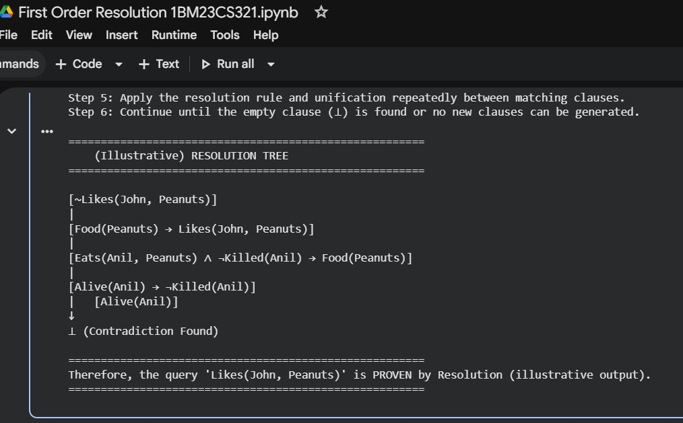
Output:

Program 10

Implement Alpha-Beta Pruning.

Algorithm:
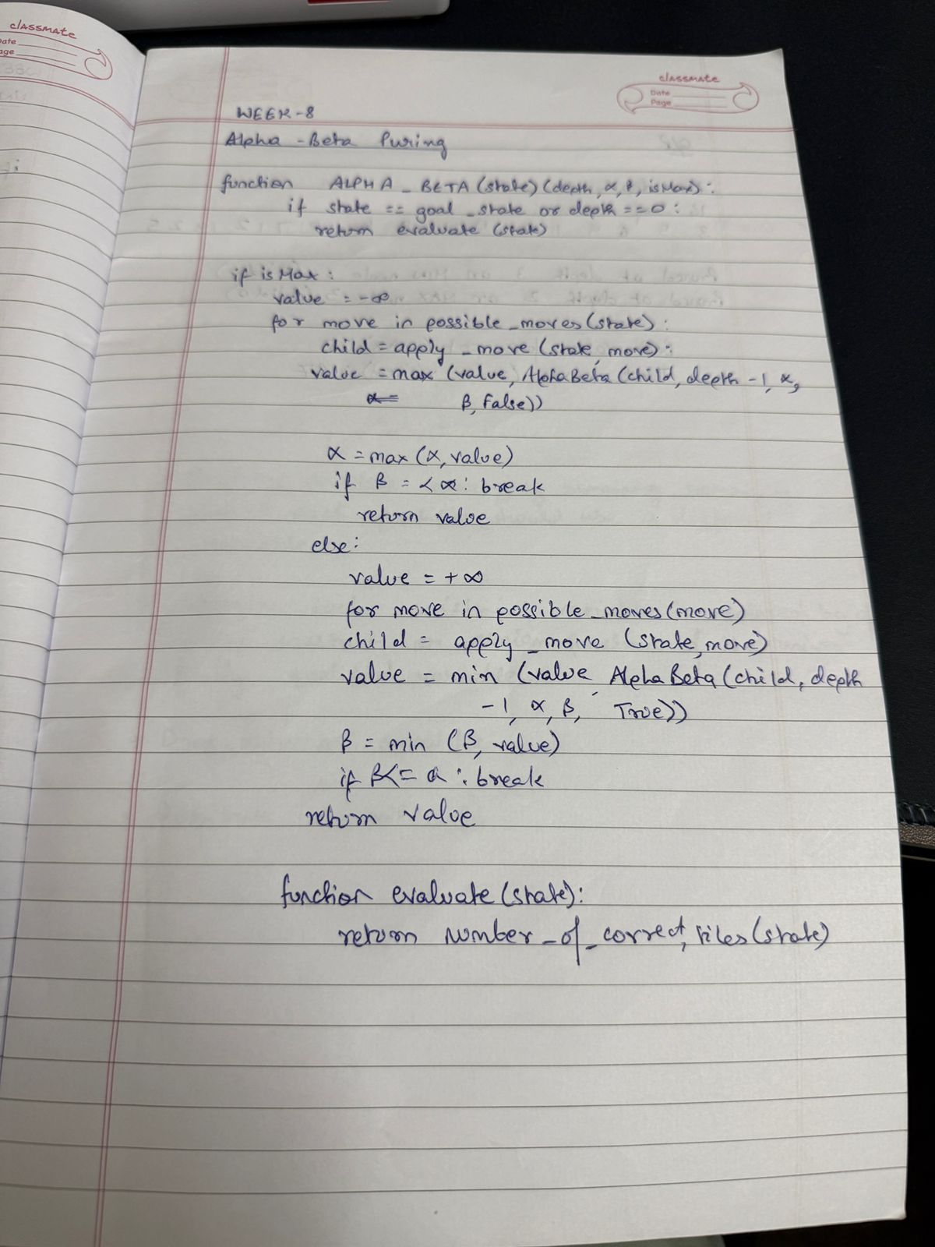

Code:
move_count = 0

def alpha_beta(depth, node_index, is_maximizing, values, alpha, beta, max_depth): global move_count
move_count += 1
if depth == max_depth: return values[node_index
]

if
is_maxim izing:
best = float('- inf')
for i in range(2): # binary tree
val = alpha_beta(depth + 1, node_index * 2 + i, False, values, alpha, beta, max_depth) best = max(best, val)
alpha = max(alpha, best) if beta <= alpha:
print(f" Pruned at depth {depth} on MAX node
{node_index}") break return best
else:
best = float('inf') for i in range(2):

val = alpha_beta(depth + 1, node_index * 2 + i, True, values, alpha, beta, max_depth) best = min(best, val)
beta = min(beta, best) if beta <= alpha:
print(f" Pruned at depth {depth} on MIN node
{node_index}") break return best
max_depth = int(input("Enter the maximum depth of the tree: ")) num_leaves = 2 ** max_depth
print(f"Enter {num_leaves} leaf node values separated by spaces:") values = list(map(int, input().split()))

if len(values) != num_leaves:
print(" Error: Number of values does not match 2^depth.") else:
move_count = 0
best_value = alpha_beta(0, 0, True, values, float('-inf'), float('inf'), max_depth) print("\n Best value for root (MAX):", best_value)
print(f" Total moves (nodes visited): {move_count}")

Output:

